**PURBANCHAL UNIVERSITY**



**DEPARTMENT OF COMPUTER ENGINEERING**

**KHWOPA ENGINEERING COLLEGE  
LIBALI-2, BHAKTAPUR**

**A MID-TERM DEFENSE REPORT**

**ON**

**FOOD FOR NEEDY**

Project work submitted in partial fulfillment of requirements for the award of the degree of Bachelor of Engineering in Computer Engineering (Fifth Semester)

**SUBMITTED BY**

Niru Kumari Mishra (740325)

Rabin Phaiju (740329)

Rodip Duwal (740334)

Roshan Dumaru (740335)

**UNDER THE GUIDENCE OF**

Er. Reena Manandhar

17 March 2020

|  |  |  |
| --- | --- | --- |
| **Chapter** | **Title** | **Page** |
|  | Title Page | i |
|  | Table of Contents | ii |
|  | Acknowledgement | iii |
|  | List of Figures | iv |
|  | List of Abbreviation | v |

**TABLE OF CONTENTS**

|  |  |  |
| --- | --- | --- |
| 1 | Introduction | 1 |
| 1.1 | Background | 1 |
| 1.2 | Statement of Problems | 1 |
| 1.3 | Objectives | 1 |
| 1.4 | Scopes | 1 |

|  |  |  |
| --- | --- | --- |
| 2 | Literature Review | 2 |
|  |  |  |
| 3 | Methodology | 3 |
| 3.1 | Background | 3 |
| 3.2 | Accomplished Work | 3 |
| 3.3 | Work to be done | 7 |
| 3.4 | Block Diagram | 7 |
| 3.5 | Tools and platform | 9 |
|  |  |  |
|  |  |  |
| 4 | References | 10 |
|  |  |  |

**ACKNOWLEDGEMENT**

We are extremely grateful to Department of Computer Engineering, Khwopa Engineering College for providing us the opportunity to work on the project named **“Food for Needy”** to explore our abilities and knowledge in the field of computing. We are extremely thankful to our supervisor Er. Reena Manandhar for providing the guidance and support throughout this project.

**Project Team Members:**

Niru Kumari Mishra (740325)

Rabin Phaiju (740329)

Rodip Duwal (740334)

Roshan Dumaru (740335)

**LIST OF FIGURES**

|  |  |  |
| --- | --- | --- |
| **Fig no.** | **Title** | **Page** |
| 3.1 | Landing page | 3 |
| 3.2 | Database | 4 |
| 3.3 | Login page | 4 |
| 3.4 | Dashboard | 5 |
| 3.5 | User profile page | 5 |
| 3.6 | Message page | 6 |
| 3.7 | Record page | 6 |
| 3.8 | Schedule page | 7 |
| 3.9 | Block diagram of “Food for Needy” | 7 |
| 3.10 | ER-Diagram | 8 |

**LIST OF ABBREVIATION**

|  |  |  |
| --- | --- | --- |
| **S.N.** |  |  |
| 1 | etc. | Etcetera |
| 2 | JS | JavaScript |
| 3 | MYSQL | Structured Query Language |
| 4 | No. | Number |
| 5 | PHP | PHP: Hypertext Preprocessor |
| 6 | S.N. | Serial Number |

**CHAPTER 1**

**INTRODUCTION**

**1.1 Background:**

Nothing brings people together like a generous spread of delicious food. It’s the universal unifier. Food serves as a cultural marker, attends every milestone and celebration, and can be dressed up or down. Food is where the heart is. Below you’ll find a collection of wise, inspirational and humorous food quotes, sayings and proverbs. Food is any substance consumed to provide nutritional support for an organism. Food waste is the disrespectful on so many levels to hungry, to the people that spends their times cooking, to our natural resource, yet it is a practice that is generally and accepted and makes fighting it so challenging.

Food rescue, also called food recovery or food salvage, is the practice of gleaning edible food that would otherwise go to waste from places such as restaurants, grocery stores, produce markets, or dining facilities and distributing it to local emergency food programs. At glance, food waste doesn’t seem like a big problem. However, if we look deep into it, wasting food has caused some serious damages. The number of food waste has increased quite significantly since 1976. In the world, 13 billion of food go to waste each year. Meanwhile, in the US, 40% of food produced never gets eaten, meaning that 165 billion dollars’ worth of food is thrown away every year. It could fill 730 football stadiums every year! Seeing how many people in the world, or even within a particular country, live in hunger and malnutrition, this situation is inequitable. Within this, there are many disadvantages of food waste, this article with cover some of those including, environmental issues, morally unacceptable in the case of fighting hunger, and the way of labor, time, as well as natural resources.

Food for Needy is a website to provide the information related to the donation of the food, donor list, distributor and sponsor list and how to provide information offered by donor and sponsor. Internet has become an ocean of information related to every aspect, which is extensive in the world. This website will act as an active platform to provide the linkage between the donor and the organization. We will update the information of surplus food to the website and thereby many food organizations and individuals will come to know about the availability of food through this website.

**1.2 Statement of problem:**

Previously in many projects there were no such effective platform that provide the linkage between the donor and the sponsor.

There was not proper display of food item’s details in user/receiver login. The previous project even lacked the display of the schedule program by the sponsor.

**1.3 Objectives**

The main objective of this project is to provide a platform that provide schedule information what a donor/sponsor offers.

**1.4 Scope**

The scope of this project is to host in web. This project is designed inconsideration to build a platform to link food donor and food receiver. It provides the schedule information and the record list of the latest activities performed.

**CHAPTER 2**

**LITERATURE REVIEW**

The literature review of this project has taken some of the references from different sites and blogs. This site such as food for all has been providing 50% discount on the surplus food of the restaurants [1 food for all]. Another related project has been providing food services for low prices as well as for free [2 groliste]. Similarly, another related project has been rescuing the surplus food and donating to real needy people [3 food rescue]. And another related project has been project has been providing awareness and information of the issues about the need of the food of particular location [4food tank].

So, here’s our project food for needy that provides schedule information and reliable messaging feature that another website was not having. Previous projects were having the problem in maintaining the records of the recent activities. Here this project maintains the schedule for the upcoming events and keeps the records of the recent activities performed. Reliable Messaging features were also absent in the project that we have referred. So, this project provides the facility that one cannot see the other’s message thus it also maintains the security [5].

Therefore, our project “Food for Needy” has some of features that we are improving and we have included the features like schedule for the upcoming events, record system of recent activities, messages between users and sending the notifications etc.

**CHAPTER 3**

**METHODOLOGY**

**3.1 Background**

Food for Needy is web-based online platform to provide the information related to donation of the food, donor list, distributor and sponsor list and how to provide information offered by donor and sponsor. The sponsor and the receiver can login to the website. This website verify the receiver if it is the organization or not. If it is an organization than the sponsor can directly contact to the organization through this website and the admin also maintains the donation of the food, donor list, distributor and sponsor list.

For the development of the such site we collected required information from different site such as Groliste, Food Rescue, Food Tank etc. & we have used markup language such as HTML, scripting language such as JS and style sheet language such as CSS etc.

**3.2 Accomplished Work**

Here we have our up-to date result listed below:

**Front End**

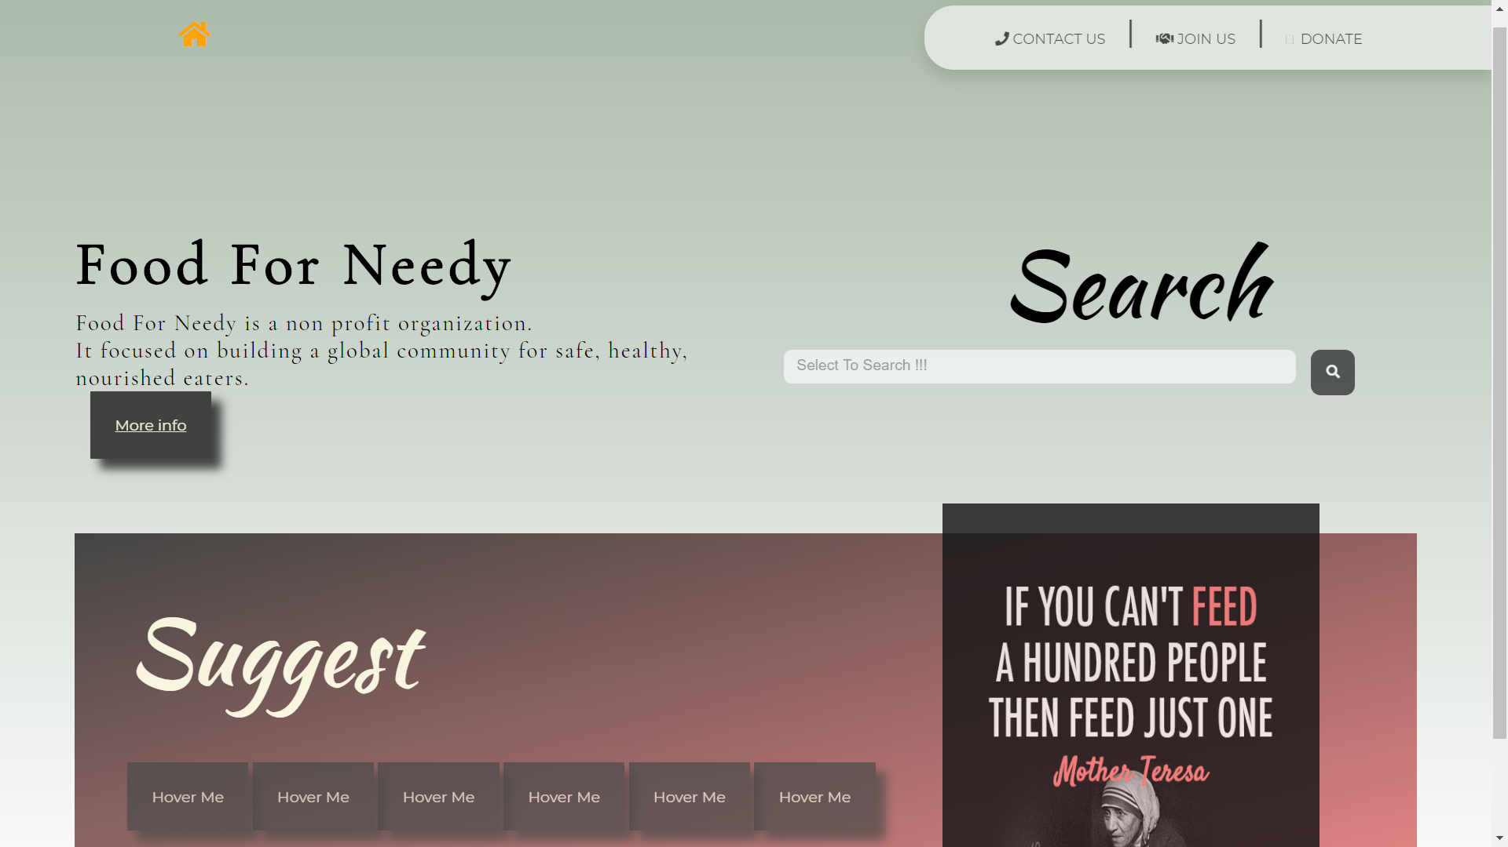

Fig 3.1 Landing page

This is the front page of our project displaying services, information about our website.

This page contains all schedules, recent activity of donors etc.

**Data base**

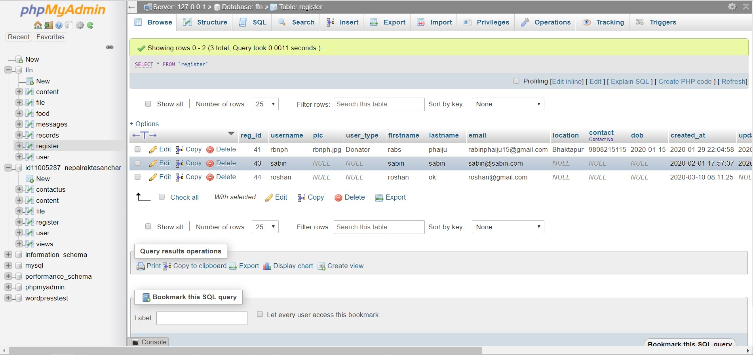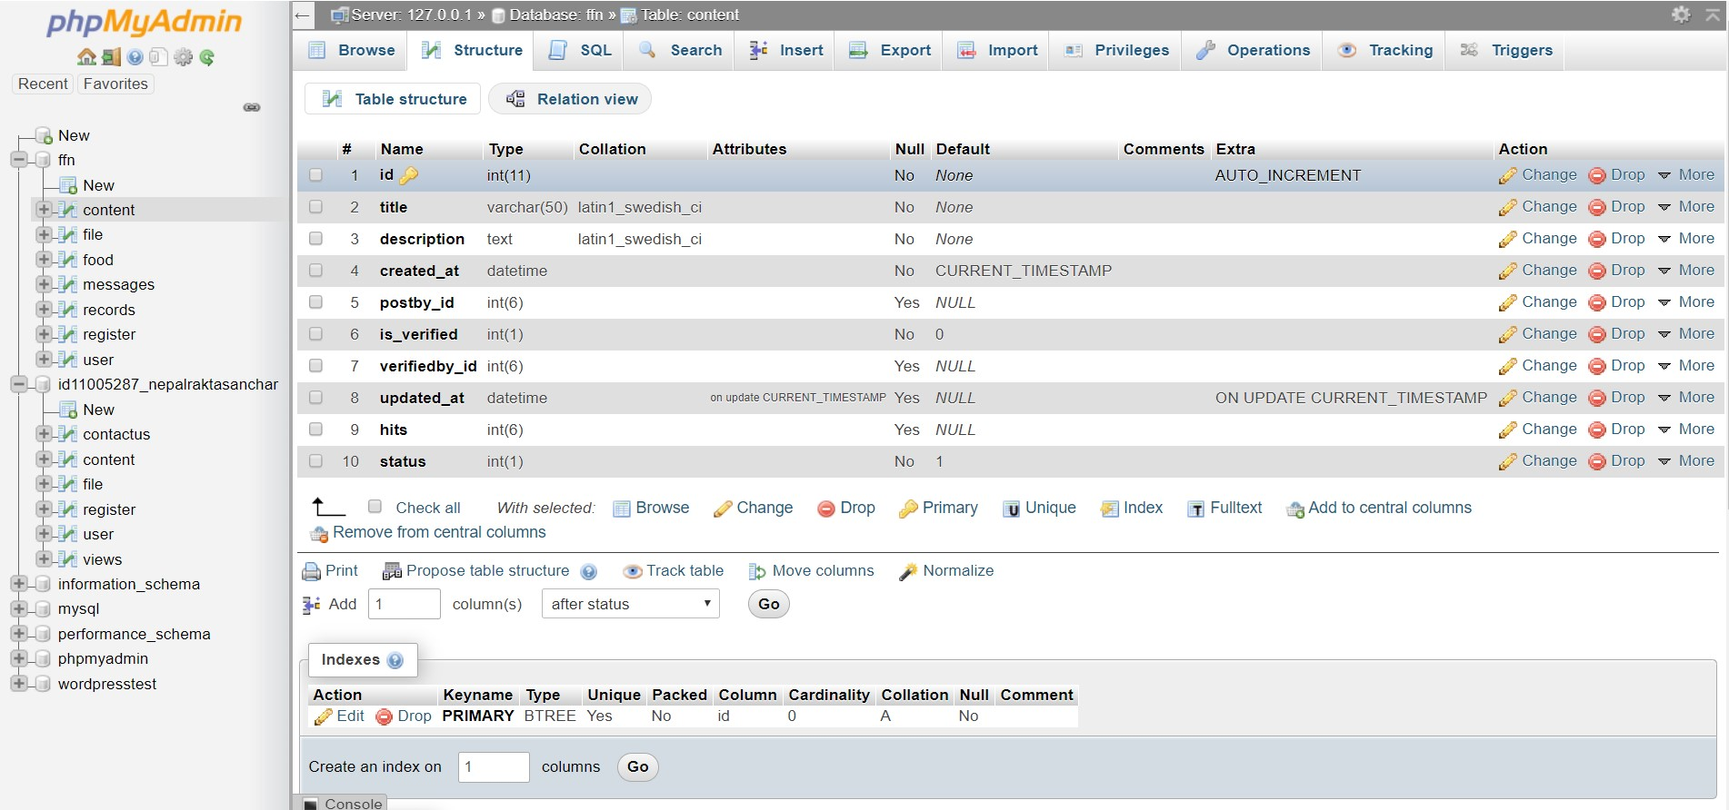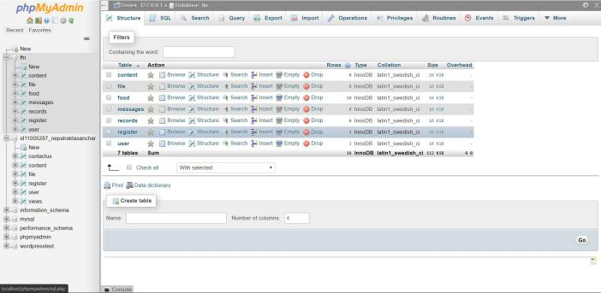

Fig 3.2 Database

This is our database system of our project. Here we have no. of tables to store data of items and login information of the user. This database stores all needed information like created date, updated date, remarks etc.

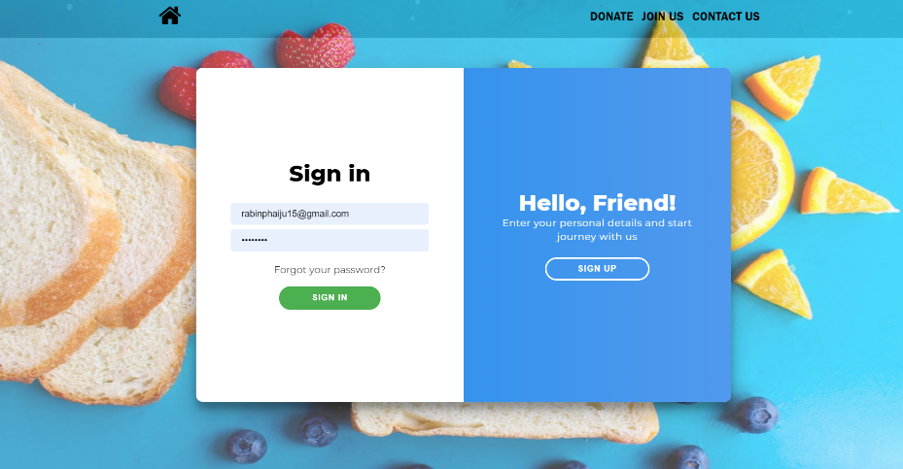**Login Page**

Fig 3.3 Login page

This is user-login page of our website. Here we can view and update user information. The add food page contain adding new items for the website. In view food, user can view item that they added and in index page all the available items are viewed.

In login user have to provide username or email and password to login. User have to provide username, name, email and password (must contain capital letter, number and total 8 digits).

**Dashboard**

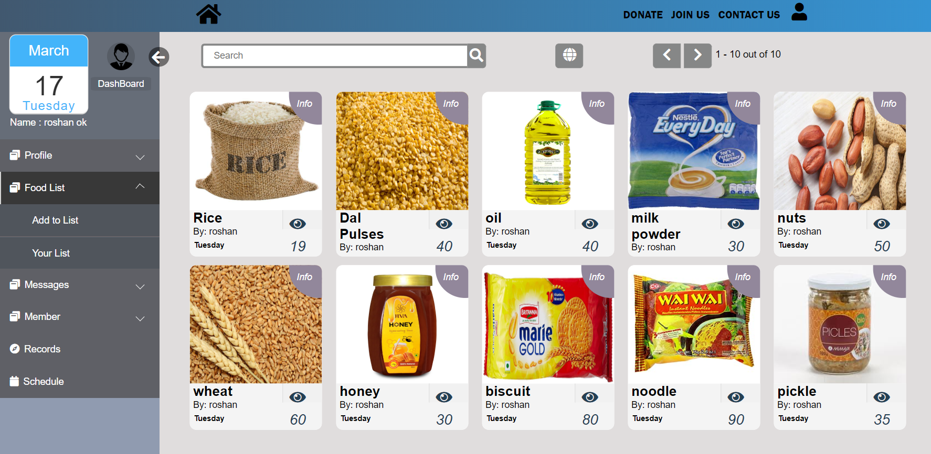

Fig 3.4 Dashboard

This is index page after user login where a user can view available food items in dashboard.

User can add and inform the respective food receiver directly.

**User Profile**

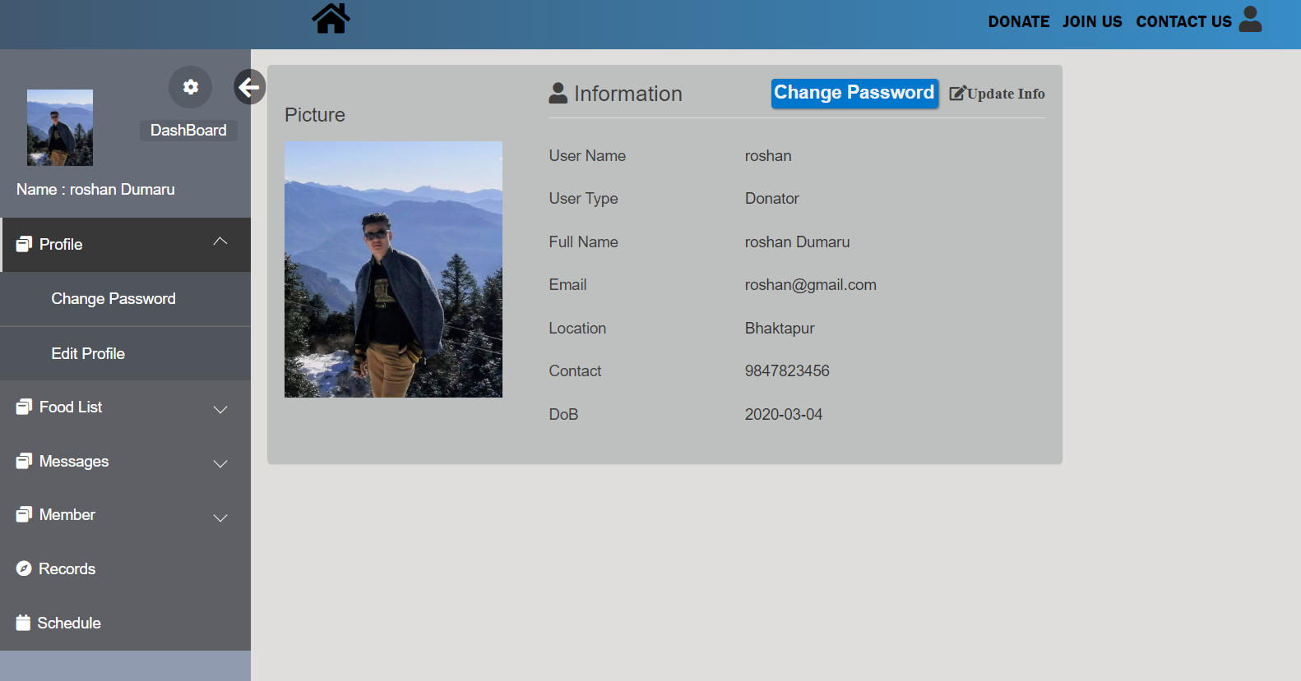

Fig 3.5 User profile page

This is a user profile page where a user can view and edit their information as well as their password.

**Message page**

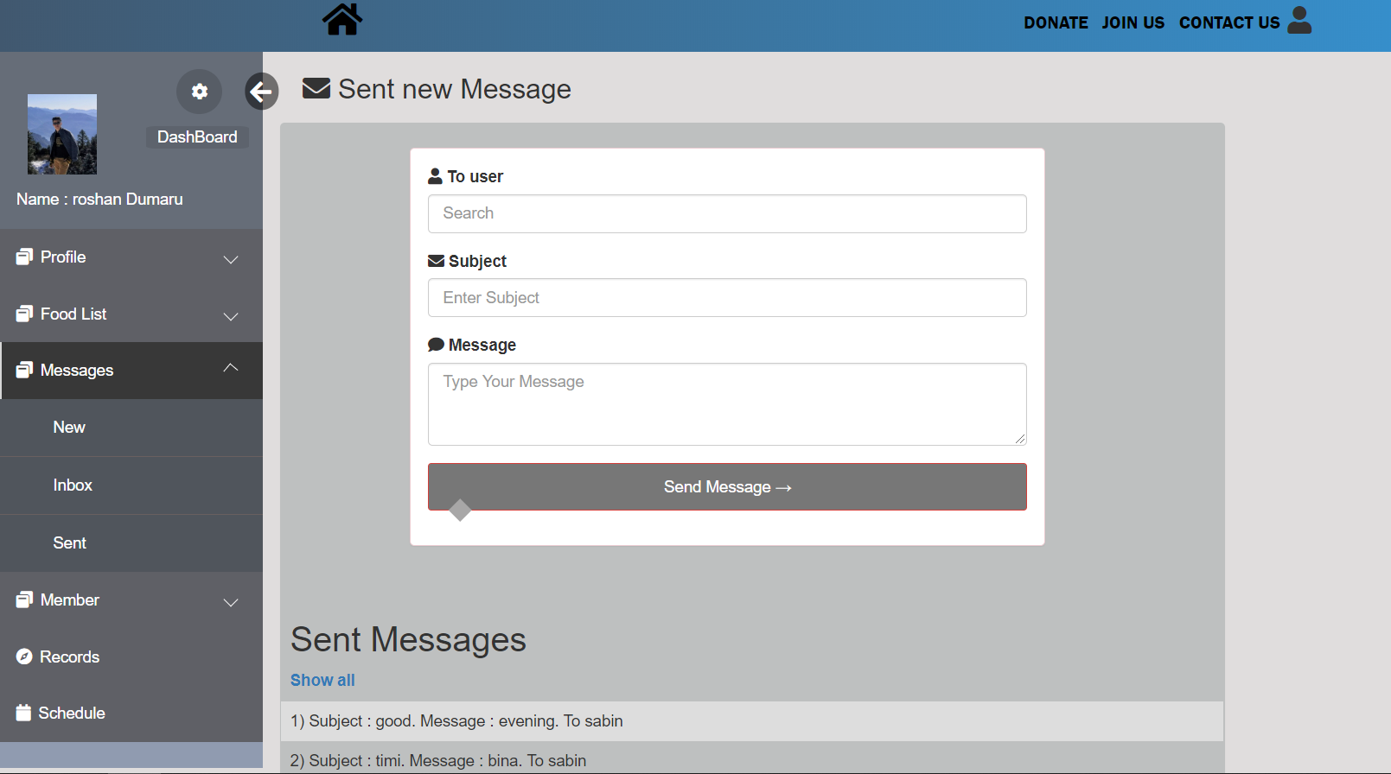

Fig 3.6 Message page

This is a message page. User can contact directly to other users (donor or receiver) through this website and even sent emails if their email id is provided.

**Record page**

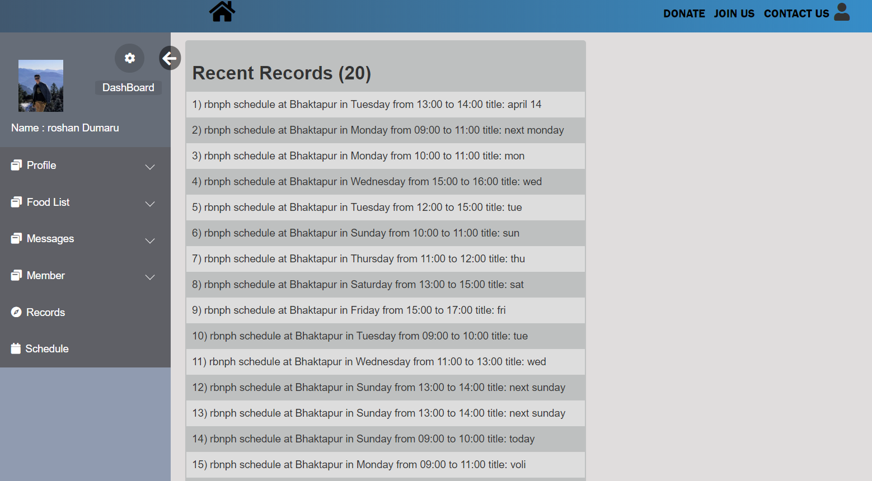

Fig 3.7 Record page

This is a recent record page where recent activities like added item, schedule, update information are viewed.

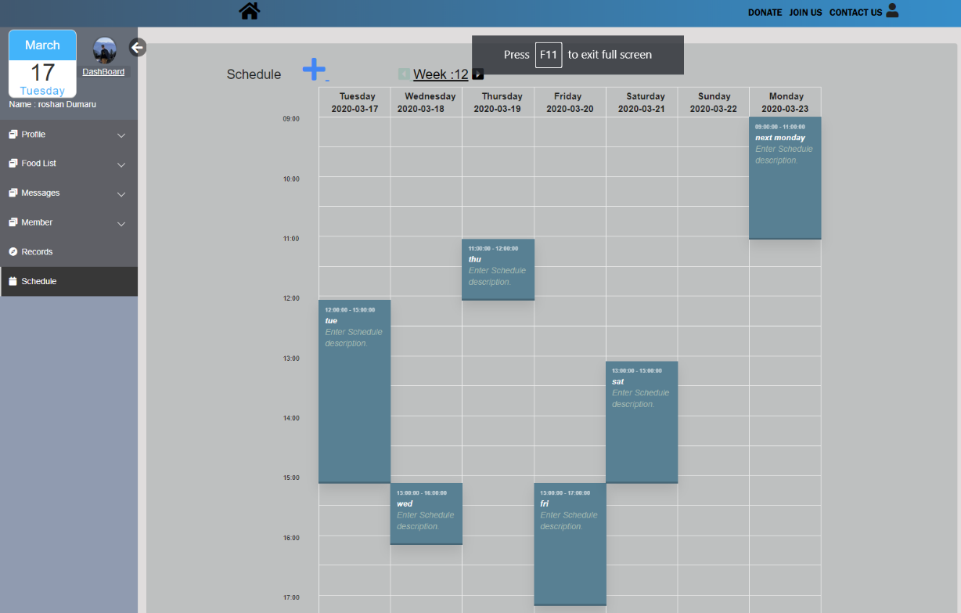**Schedule page**

Fig 3.8 Schedule page

This is schedule page where schedule from the current date to future are shown. Donor or sponsor can add schedule to a particular organization of receiver to donate.

**3.3 Works to be done**

Some of the works are still to be done in order to complete our project which are:

* Improvement in Front End (Adding Splash Screen, Scroll up).
* Improve Back End Features such as adding category.
* Adding direct message features with donor and receiver

**3.4 Block Diagram**

Fig 3.9: Block diagram of Food for Needy

Login

Provider

Receiver

Name

Address

Phone Number

E-mail

Firm Name

Description

**ER-Diagram**

M

1

Receiver

Provider

Foods

provide

Receive

M

M

M

Has

LOG-IN

Fig 3.10 ER-Diagram

**3.5 Tools and Platforms**

During the development of the project, the tools and platforms that we used for coding and testing the project are:

1. Visual Studio Code

2. Web Browser

3. PHP

4. Git Hub

5. Apache Server

6. Sub-lime Text

**CHAPTER 4**

**REFERENCES**

[1] www.groliste.com/groliste.com [11/12/2019] edit it

[2] www.foodtank.com/about.html [11/13/2019]